**Unit 7: Database Design and Implementation**

**Database Design** is a collection of processes that facilitate the designing, development, implementation and maintenance of enterprise data management systems. Properly designed database are easy to maintain, improves data consistency and are cost effective in terms of disk storage space. The database designer decides how the data elements correlate and what data must be stored.

The main objectives of database design in DBMS are to produce logical and physical designs models of the proposed database system.

The logical model concentrates on the data requirements and the data to be stored independent of physical considerations. It does not concern itself with how the data will be stored or where it will be stored physically.

The physical data design model involves translating the logical DB design of the database onto physical media using hardware resources and software systems such as database management systems (DBMS).

**In this Database design tutorial, you will learn-**

* [Why Database Design is Important ?](https://www.guru99.com/database-design.html#2)
* [Database development life cycle](https://www.guru99.com/database-design.html#3)
* [Requirements analysis](https://www.guru99.com/database-design.html#4)
* [Database designing](https://www.guru99.com/database-design.html#5)
* [Implementation](https://www.guru99.com/database-design.html#6)
* [Types of Database Techniques](https://www.guru99.com/database-design.html#7)

**Why Database Design is Important ?**

It helps produce database systems

1. That meet the requirements of the users
2. Have high performance.

Database design process in DBMS is crucial for **high performance** database system.

Note, the genius of a database is in its design. Data operations using SQL is relatively simple

**Database development life cycle**

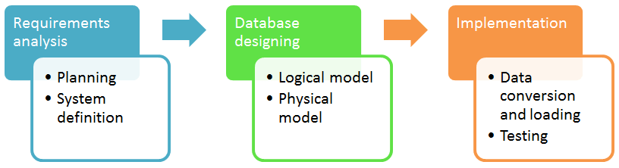

The database development life cycle has a number of stages that are followed when developing database systems.

The steps in the development life cycle do not necessarily have to be followed religiously in a sequential manner.

On small database systems, the process of database design is usually very simple and does not involve a lot of steps.

In order to fully appreciate the above diagram, let’s look at the individual components listed in each step for overview of design process in DBMS.

**Requirements analysis**

* **Planning** – This stages of database design concepts are concerned with planning of entire Database Development Life Cycle. It takes into consideration the Information Systems strategy of the organization.
* **System definition** – This stage defines the scope and boundaries of the proposed database system.

**Database designing**

* **Logical model** – This stage is concerned with developing a database model based on requirements. The entire design is on paper without any physical implementations or specific DBMS considerations.
* **Physical model** – This stage implements the logical model of the database taking into account the DBMS and physical implementation factors.

**Implementation**

* **Data conversion and loading** – this stage of relational databases design is concerned with importing and converting data from the old system into the new database.
* **Testing** – this stage is concerned with the identification of errors in the newly implemented system. It checks the database against requirement specifications.

**Two Types of Database Techniques**

1. **Normalization**
2. **ER Modeling**